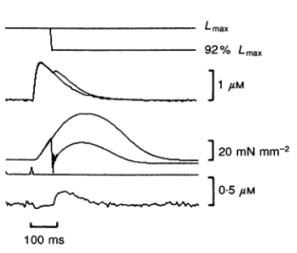

Kurihara vs. Megan Model quick-release comparison. QR adjusted in the Megan Model to occur at roughly the same point of active stress development.

|  |  |
| --- | --- |
| Figure 3 |  |

Old Kurihara/ Megan-model quick-release comparison.